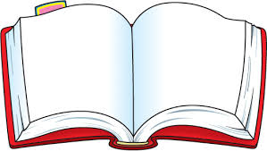

**Novel**: ____________________________________

**Author**: ___________________________________

**Genre**: ___________________________________

**Characteristics**: ______________________

**Point of View**: ______________________________

**Supporting Words**: ____________________

**Audience**: ___________**Author’s Purpose**:_________

_________________________________________



**S = Setting** clues or changes

**Time**  pp. _____________________

**Place**  pp. _____________________

**H = Hard word** to understand pp. _______________

**A = Alliteration**  pp. _____________________

**R =** Recognize good **word choice** pp. ____________

**P** = **Personification** pp. _____________________

**R** = Recognize change in **plot** pp. _______________

Change in **character** pp. _______________

**E =** Explore a **forming problem** pp. ______________

**Solution** pp. _______________

**A** = **Anticipate** something pp. _______________

**D** = Discover a **simile** pp. _______________

**Metaphor** pp. _______________

**Idiom** pp. _______________

**Hyperbole** pp. _______________

**E** = Examine **author’s purpose** pp. _______________

**R** = Recognize the **mood** or **tone** pp. ______________

Make a **prediction** at the end of chapter: _____________

________________________________________________________________________________________

Was your **prediction** correct? _____________________



**Cause**: ______________________________________

____________________________________________

**Effect**: ______________________________________

____________________________________________



Sentence from the book that uses good **imagery**: _______

____________________________________________

____________________________________________

What **senses** can your imagination recognize? __________

____________________________________________



State the following about the main character or event:

**A Fact**: ______________________________________

____________________________________________

**An Opinion**: ___________________________________

____________________________________________



Compare and contrast two characters or events from the book. 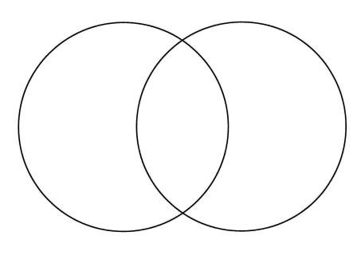



Character: _________________Trait: _____________

Describe a scene where the character’s actions are indicative of this trait:___________________________

____________________________________________________________________________________________________________________

**Sharp**

**Reader**

Write a sentence from the book that shows **denotation**: ________________________________

_________________________________________Write a sentence from the book that shows **connotation**: _______________________________

_________________________________________



Write a sentence from the text: ________________

_________________________________________

What **inference** can be made from this sentence? _________________________________________

_________________________________________



**Context Clues:** Find an unfamiliar word in the book that can be defined using context clues. Write the sentence and circle the word. Underline the word or words that give hints to the definition of the word.

Sentence: _________________________________

_________________________________________



What is the **main idea** of the chapter? ___________

_________________________________________

__________________________________Ch.#___

What are the **supporting details**? _______________

_________________________________________

**Theme**: ___________________________________

**Moral**: ___________________________________



Write an example of **foreshadowing**: _____________

_________________________________________

Write an example of a **flashback**: _______________

_________________________________________

Write an example from the story that contains **suspense**: _________________________________

________________________________________

**Stereotype** - A character whose personality traits represent a group rather than an individual.

Give an example of **stereotype**: _________________

_________________________________________



**Oxymoron** – A combination of contradictory words.

Example: __________________________________

**Irony** – The use of tone, exaggeration, or understatement to suggest the opposite of the literal meaning of the words used.

Example: __________________________________

**Archaic Language** – Language that was once common in a particular time period.

Example: __________________________________

Plot Line

Climax

Resolution/

Conclusion

**Characters**: ___________________________________________

____________________________________________________**Protagonist**: __________________**Antagonist**:________________

**Character Development**: How did the character change over time? __________________________________________________________________________________________________________

Exposition/

Introduction

**Anticlimax** – An event less important than the one before it.

Example: __________________

_________________________

_________________________

__________________________________________________

Falling Action/

Denouement

Conflict

Rising Action